**Scripting Task**

1.Create a shell script to print the HTTP error code of guvi.in & print, the success/failure message based on the error code response

Bash Script:

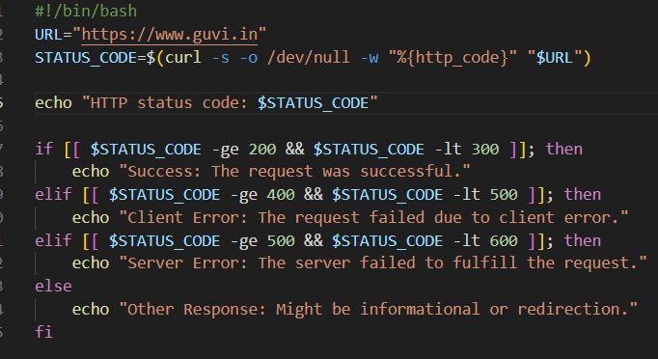

P.T.O ….

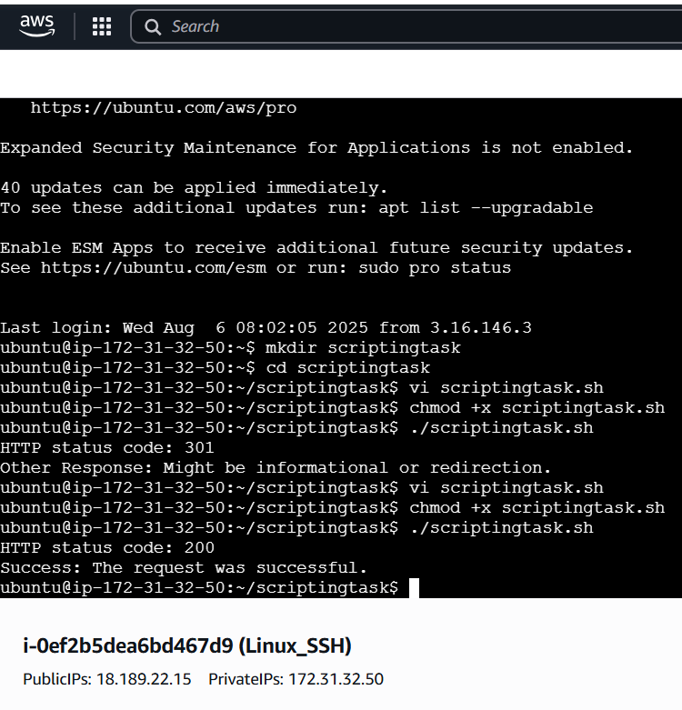

2) Given a file, replace all occurrence of the word "give" with "learning" from 5th line till the end in only those lines that contain the word "welcome"

Sample file:

Line one

Line two

Line three

Line four

welcome to the course, we learning you access

this line has give but no welcome

welcome again, we learning more no match here

